# **Assignment 6**

# 1 Usability Testing

Usability testing is an essential component of software development. The process involves testing a product with real users to identify design, functionality, and user experience issues, thus, cannot be automated fully. The feedback received from the rounds of usability tests is used to improve the product. Thus, it is ensured that the product meets the needs and expectations of its intended audience. While some aspects of usability tests can be automated, such as data collection and analysis, testing must be conducted with human input.

### **Usability testing examples**

As is always more intuitive to have a reality like example, we will try to present you here some usability testing scenarios examples.

****A)**** Let’s use as a usability testing example for ****shoe e-commerce platform****:

Scenario: you are currently looking for a new pair of shoes, you want to buy them on shoesecommerce.com

In this case, a typical task could be:

“go on shoesecommerce.com and buy the red Adidas Campus shoes, size 5”

## 2 Smoke Testing

**Smoke Testing** is a software testing method that determines whether the employed build is stable or not. It acts as a confirmation of whether the quality assurance team can proceed with further testing. Smoke tests are a minimum set of tests run on each build. Smoke testing is a process where the software build is deployed to a quality assurance environment and is verified to ensure the stability of the application. Smoke Testing is also known as ***Confidence Testing*** or ***Build Verification Testing***.

In other words, we verify whether the important features are working and there are no showstoppers in the build that are under testing. It is a mini and quick regression test of major functionality. Smoke testing shows that the product is ready for testing. This helps in determining if the build is flawed to make any further testing a waste of time and resources.

## **When do we do smoke testing ?**

Smoke Testing is done whenever the new functionalities of software are developed and integrated with existing build that is deployed in QA/staging environment. It ensures that all critical functionalities are working correctly or not

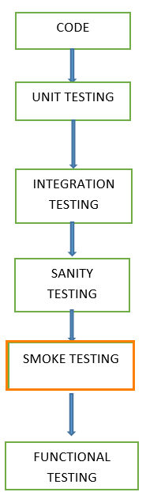

.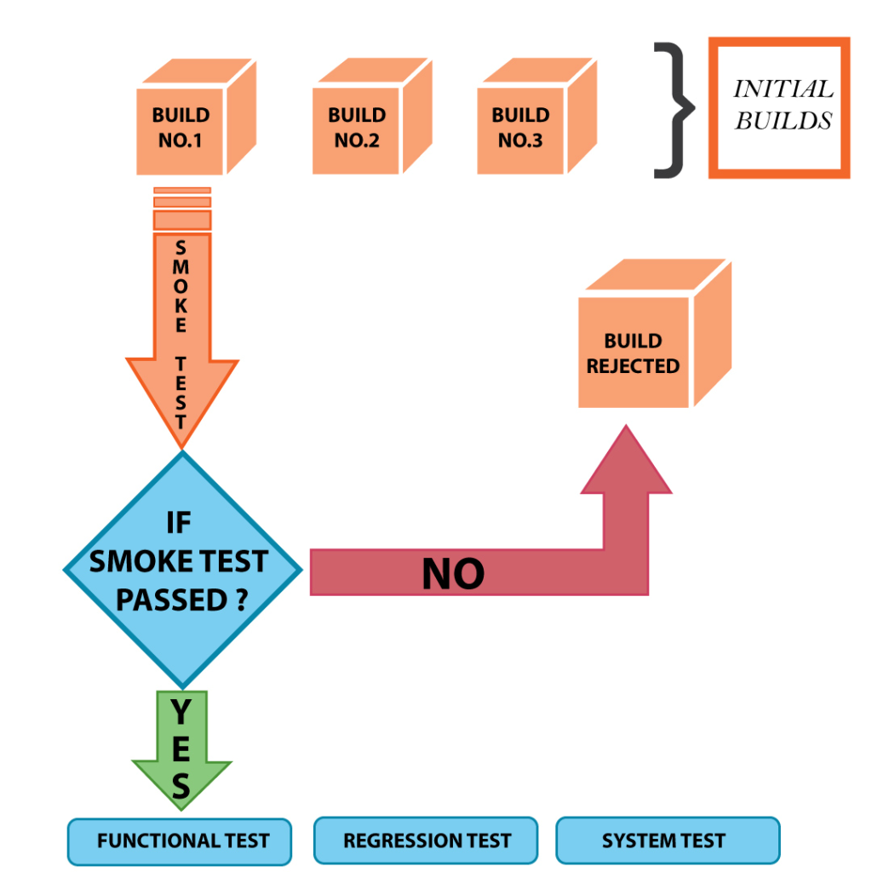

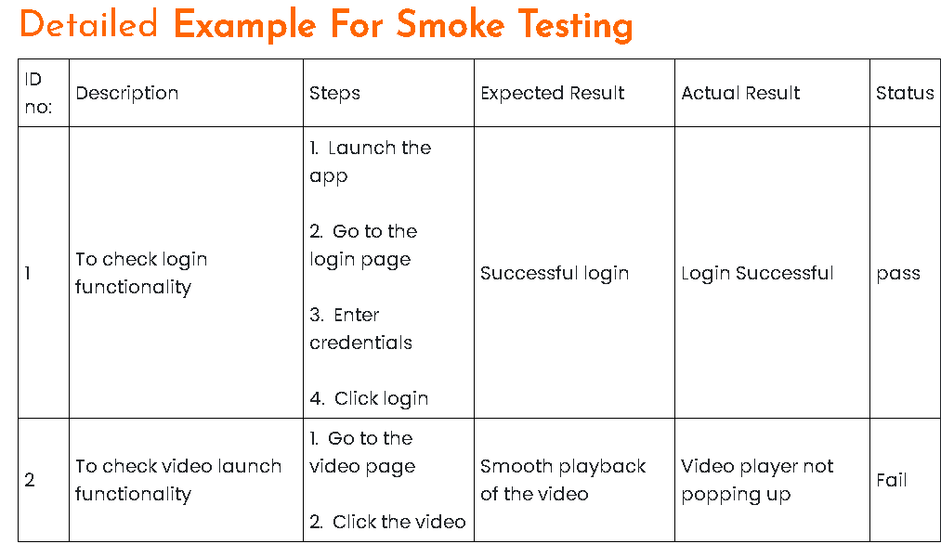

## ****3 UI Testing****

UI testing is the process to validate both the functionality and visual aspects of the User Interface of an application. It focuses more on testing what the end users see and interact with instead of the inner workings on the backend.

It should be noted that UI testing is a much broader term than GUI (Graphical User Interface) testing. UI is all of the ways that a person interacts with a machine (including graphical and non-graphical ways), while GUI only counts the ways that involve the use of graphics on displays. From this perspective, testing how well a keyboard interacts with a website would be considered UI testing, but not GUI testing. 

Although UI testing and GUI testing are not technically similar, they are still used interchangeably because GUI is the most common form of UI for computers today.

## **How does **testing user interfaces** work?**

iOS UI testing or Android UI testing generally focuses on the functionality and performance of the application’s graphical user interface. First, commonly occurring UI defects should be tested and improved, such as button alignment issues, incomplete fields, resizing issues, overlapping of fields, browsing issues, inconsistent space between textboxes or labels, misaligned data pages, and so forth. Then a more profound performance and visual experience of the user interface is checked to [ensure the expected performance](https://www.headspin.io/solutions/performance-optimization" \t "https://www.headspin.io/blog/_blank) of the application.